Pharmacy Management System

Low Level Design(LLD)



Table of Contents

**1.0 Document Purpose**

**2.0 Intended Audience**

**3.0 Project Background, Objective(s)**

**3.1 Project Background**

**3.2 Project Objective**

**4.0 Solution Diagram**

**5.0 Architectural Diagram............................................................................**

**6.0 DataFlow Diagram...................................................................................**

**7.0 ER Diagram............................................................................................**

**8.0 Use Case Diagram..................................................................................**

**9.0 Solution Steps**

**10.0 Classes/function name**

**11.0 Data Models/Tables................................................................................**

# 

# 1.0 Document Purpose

This document describes the solution architect of pharmacy management system.

This contains the problem statement which discusses the difficulties that the pharmacy management faced and it is considered as the reason why the project is proposed.

**Problem Statement:** Most pharmacies faced problems such as lack of coherence of pharmacy services in hospitals, poor drug information systems, and the inconsistency of the pharmacy information management due to its manual processes. Now, these are the problems that must be solved with this Pharmacy Management System Project Proposal.

**Solution**: Pharmacy Management System Project is a great system for storing data, maintaining, and organizing the use and process of medications in the pharmacy. This computer software is programmed to perform the various tasks required in the operation of a pharmacy. The system will improve the efficiency of the pharmacy and enable the storing of digital record such as sales report,placed orders etc.

**2.0 Intended Audience**

This document is intended as a reference for the following roles :

* Pharmacists- They can use this document for understanding how the application ease the manual process.
* Doctors-The doctors as a costumer can view this document and take the advantage of easy purchase of medicines from pharmacies.
* Medicine Suppliers- As suppliers they can use this document for promoting their business of drugs supplies. They can contact the pharmacy to sell their medicines.
* Developers- This document is used for detail design and implantation approach to align with pharmacy management services
* Solution Architects-This document helps To ensure solution design and architecture is aligned to business requirements

# 3.0 Project Background, Objective(s)

## 3.1Project Background

## The pharmacy management system is intended to increase accuracy, safety, and efficiency in the pharmacy. It is a computer-based system that stores important information and makes medical stores run better.

## 3.2 Project Objective

Pharmacists can use the Pharmacy Management System program to help them methodically manage their pharmacies. When a medicine’s name is input, the Pharmacy Management System can help by providing details about the medicine. A computer displays information about the medicine, such as its dosage and expiration date. In large medical stores, manually handling the specifics of all the drugs becomes very tough. We can keep track of all the medicines by using this pharmacy management system.

**4.0 DESIGN PATTERN:-**

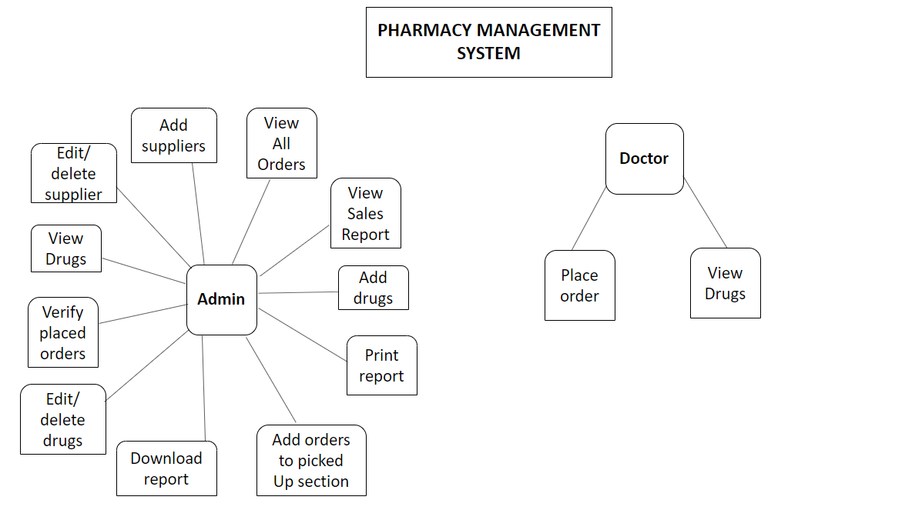

**5.0 Architectural Diagram of microservices:**

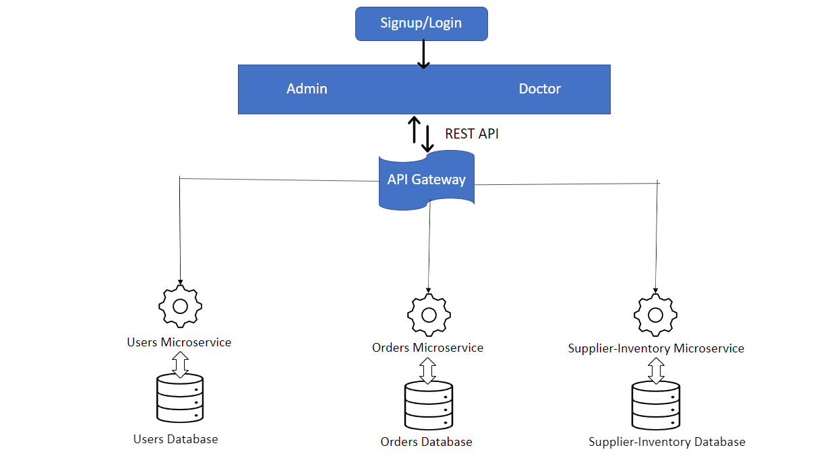

**6.0 Data flow Diagram**

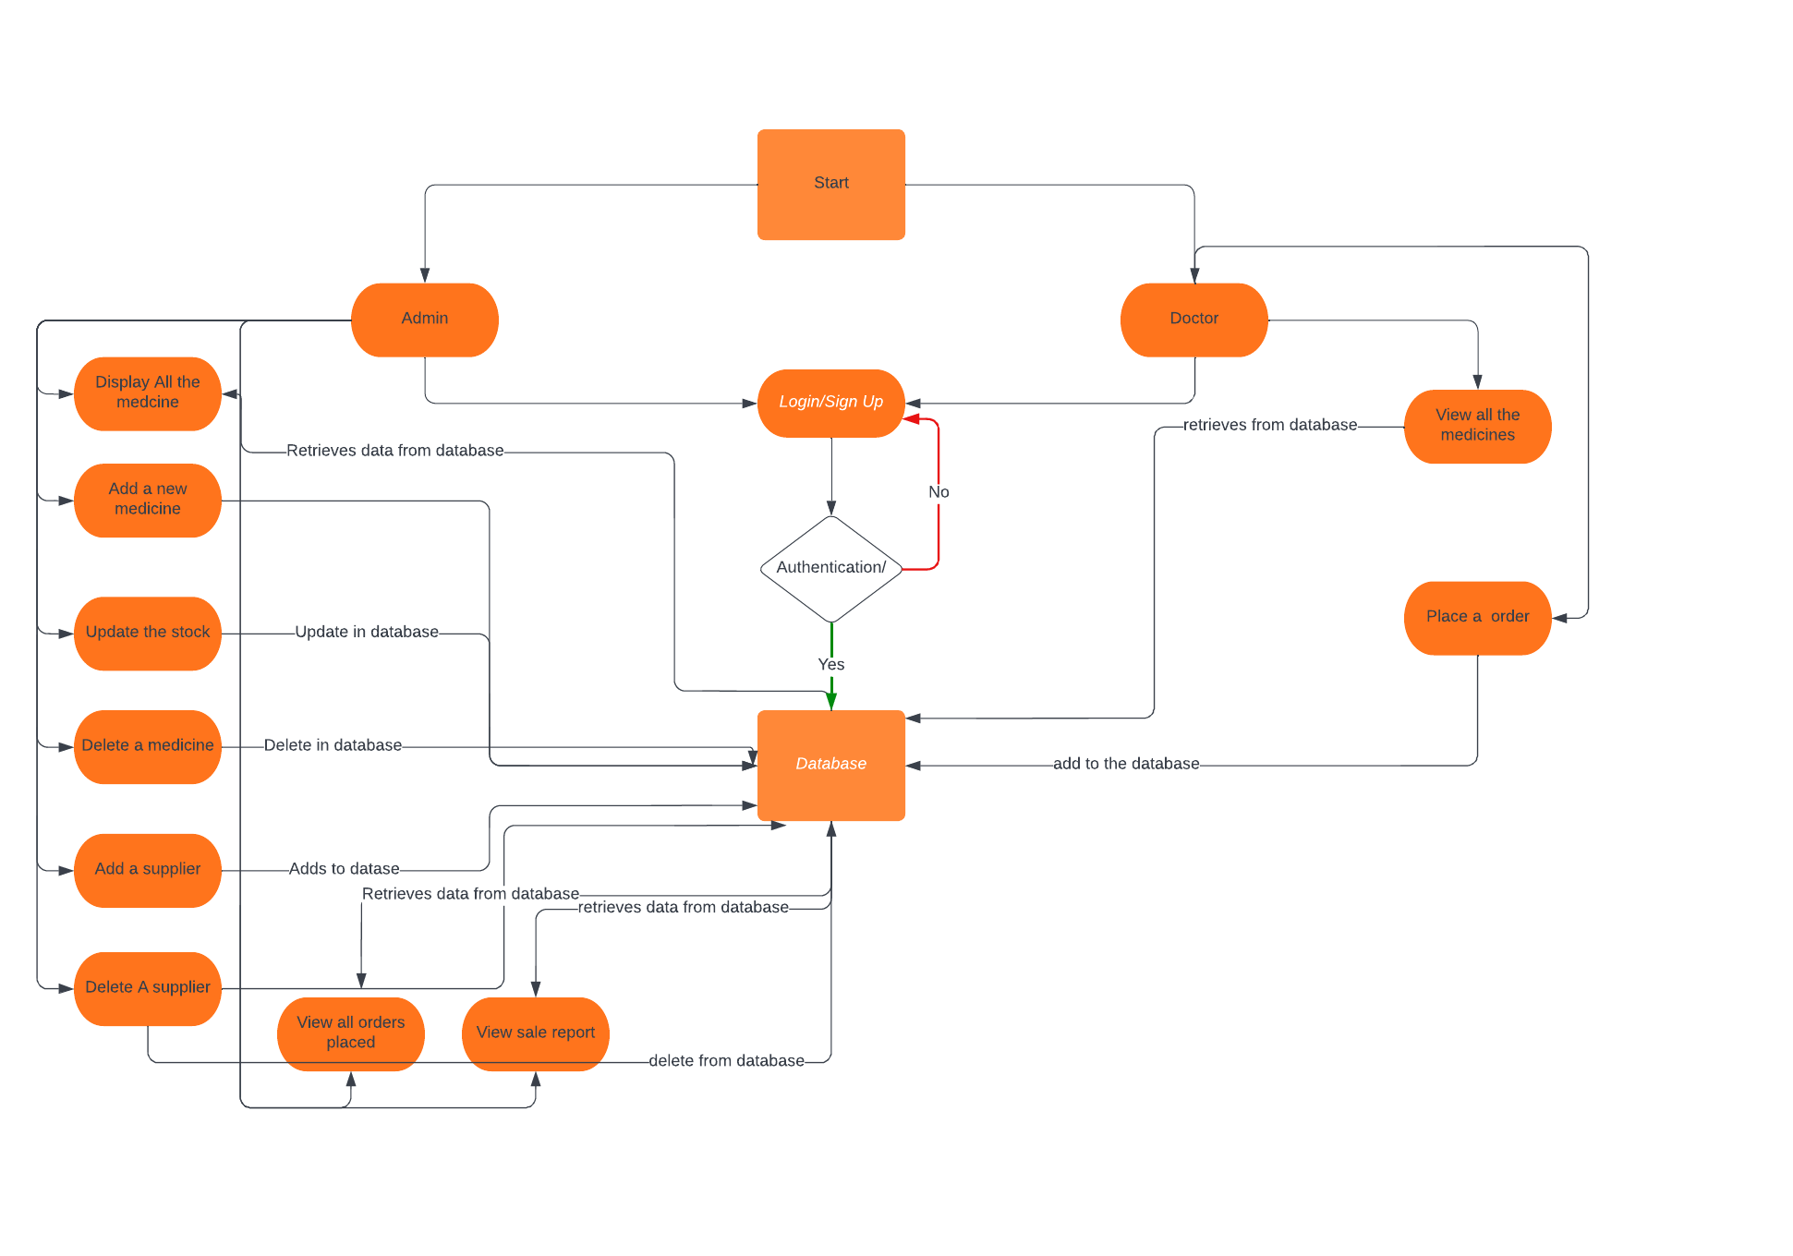

**7.0 ER Diagram**

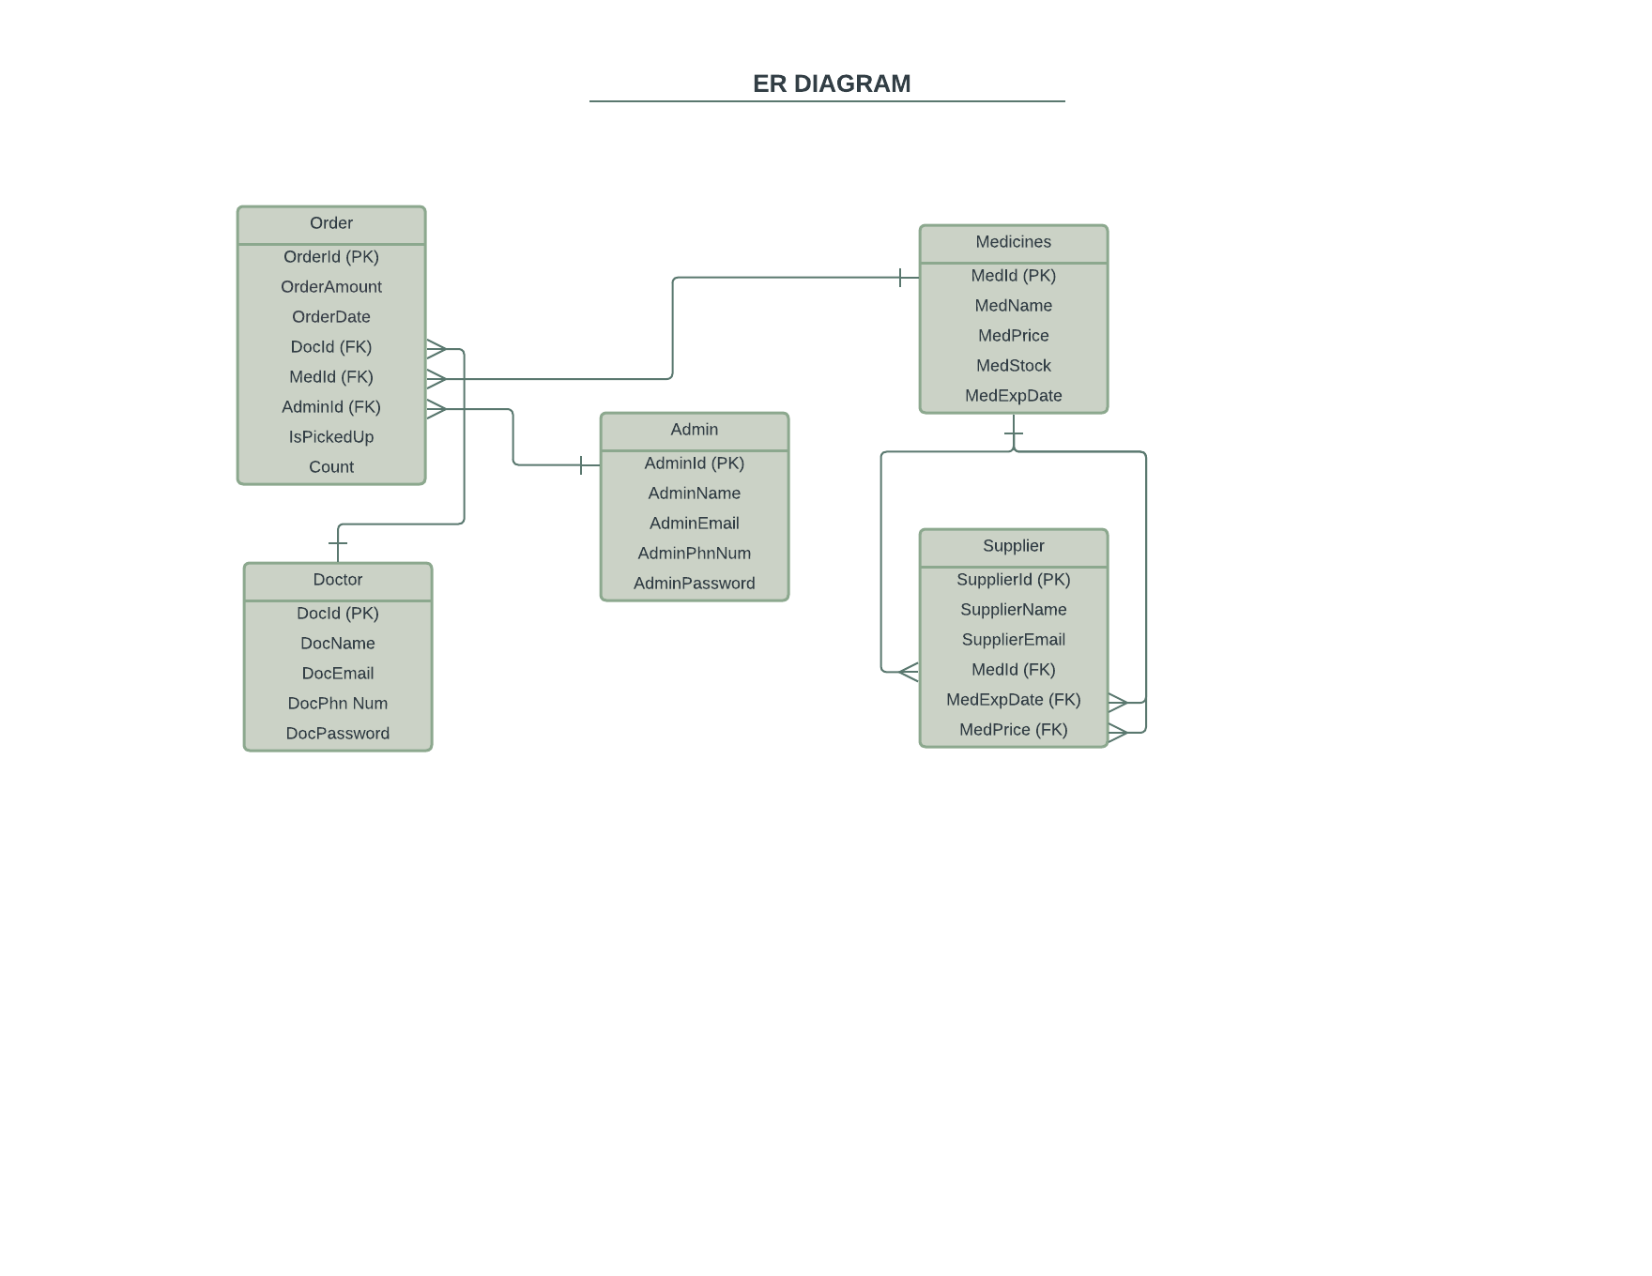

**8.0 Use Case Diagram-**

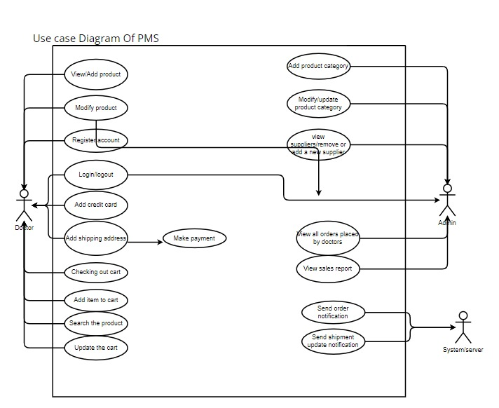

**9.0 solution steps**

LogIn OR Signup page-

**Admin**

* Admin can signup as a new admin by entering the name,phone number,email,password.
* This redirects the admin to login page. Here the admin will enter the email address and password.If validation fails, then it will return the error code and error description.
* If validation is successful, then the admin logs in successfully.
* This redirects admin to welcome page.

**Doctor**

* Doctor can signup as a new admin by entering the name,phone number,email,password.
* This redirects the doctor to login page. Here the doctor will enter the email address and password.If validation fails, then it will return the error code and error description.
* If validation is successful, then the admin logs in successfully.
* This redirects doctor to welcome page.

**Admin page-**

There will be four buttons- Medicines,sellers,orders,sales Report

* ***Medicine page-***

This will display all medicines in stock with their name,quantity,price,stock,expiry date.

Admin can view all medicines available.

Add new medicines

Update the stock of medicines

Delete the medicines

* ***Supplier page-***

Adimin can view all suppliers in the database

Can remove or add a new supplier

* ***Order page-***

Admin can view all orders placed by the doctors

He can verify the orders and put it into picked up section

* ***Sales report page-***

This will summarize all the orders placed and show the total sales.

**Doctor page-**

***Drug Inventory Page-***

This displays all the medicines available in the pharmacy.

The doctor can view the details.

He can add the quantity and add to cart.

***Cart page-***

This will show the summary of all the purchased item and total amount.

# 

# 10.0Classes/function

*10.1 Data Access layer-*

*AccountDataAccess.cs-*

|  |  |
| --- | --- |
| AddUser() | This will add a new user to database when a user signup. |
| GetUserById() | This can display a user details by its id |
| DeleteUser() | This will delete a user when the id is given as input |
| GetAllUser() | This will display the list of all the users |

*DoctorsDataAccess.cs-*

|  |  |
| --- | --- |
| AddDoctor() | This will add a new doctor to database by the admin |
| DeleteDoctor() | This will delete a new doctor from the database by the admin |
| UpdateDoctor() | This will update details of a doctor in the database by the admin |

*DrugsDataAccess.cs-*

|  |  |
| --- | --- |
| GetAllDrugs() | This will display all the drugs available in store |
| GetDrugByName() | This will search a drug by its name |
| DeleteDrugByID() | This will delete a drug from database by id |
| AddDrug() | This will add a new drug to the database |
| UpdateDrugByStock() | The admin can update the stock |

*SupplierDataAccess.cs-*

|  |  |
| --- | --- |
| AddSupplier() | This will add a new supplier to database by the admin |
| GetAllSuppliers() | This will display the supplier list in database |
| DeleteSuppler() | This will delete a new supplier from the database by the admin |

# 

# 11.0 Data model/Table

**Admin**

|  |  |
| --- | --- |
| AdminId(PK) | INT |
| AdminName | VARCHAR(25) |
| AdminPhnNum | DOUBLE |
| AdminEmail | VARCHAR(255) |
| AdminPassword | VARCHAR(25) |

**Doctor**

|  |  |
| --- | --- |
| DocId(PK) | INT |
| DocName | VARCHAR(25) |
| DocPhnNum | DOUBLE |
| DocEmail | VARCHAR(255) |
| DocPassword | VARCHAR(25) |

**Medicines**

|  |  |
| --- | --- |
| MedId(PK) | INT |
| MedName | VARCHAR(25 |
| MedPrice | INT |
| MedStock | INT |
| MedExpDate | Timestamp with time zone |

**Supplier**

|  |  |
| --- | --- |
| SupplierId(PK) | INT |
| SupplierName | VARCHAR(25) |
| SupplierPhnNum | DOUBLE |
| SupplierEmail | VARCHAR(255) |
| MedId | INT |
| MedPrice | INT |
| MedExpDate | INT |

Order

|  |  |
| --- | --- |
| OrdreId(PK) | INT |
| Amountt | INT |
| OredrDate | Timestamp with time zone |
| DocId | INT |
| MedId | INT |
| AdminId | INT |
| IsPickedUp | Bool |
| Count | INT |